EENG 385 - Electronic Devices and Circuits

Audio Board: Amplifier Measurements

Lab Handout

# Objective

The objective of this lab is to configure, use, and analyze the audio amplifier on the Audio board.

# Audio Amplifier Calibration

The heart of the Audio Amplifier is shown in the schematic shown in Figure 1. Today you will calibrate the bias voltage and Vbe voltage and then use your audio amplifier. To do this, you will need to refer to your previous week’s lab calculations. So before you start, access this document and keep it handy.

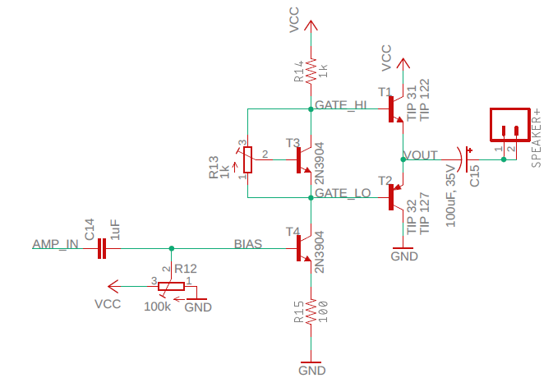

Figure : The core of the audio amplifier consists of a voltage gain stage followed by a current gain stage.

**20 Turn Potentiometer**

Last week you soldered in a pair of 20-turn potentiometers, a 1kΩ and 100kΩ like that shown in the left side of Figure 2. Look closely at the notation imprinted on the surface of the potentiometer in Figure 2 and you will see the letters “CW” printed next to the number 3. This means that as you turn the brass adjustment screw in a ClockWise (CW) direction the center tap (terminal 2) moves closer to the left pin (terminal 3). This is accomplished using a worm drive mechanism; the brass adjustment screw engages a gear attached to the center tap. The geared center tap moves around the carbon track connecting terminals 1 and 3. The worm drive acts like a gear reduction; this means that you need to rotate the brass adjustment screw 20 times to move the center tap from terminal 1 to terminal 3 (or vice versa). Note that the rotating the brass adjustment screw CounterClockWise (CCW) moves the center tap towards the right pin (terminal 1).

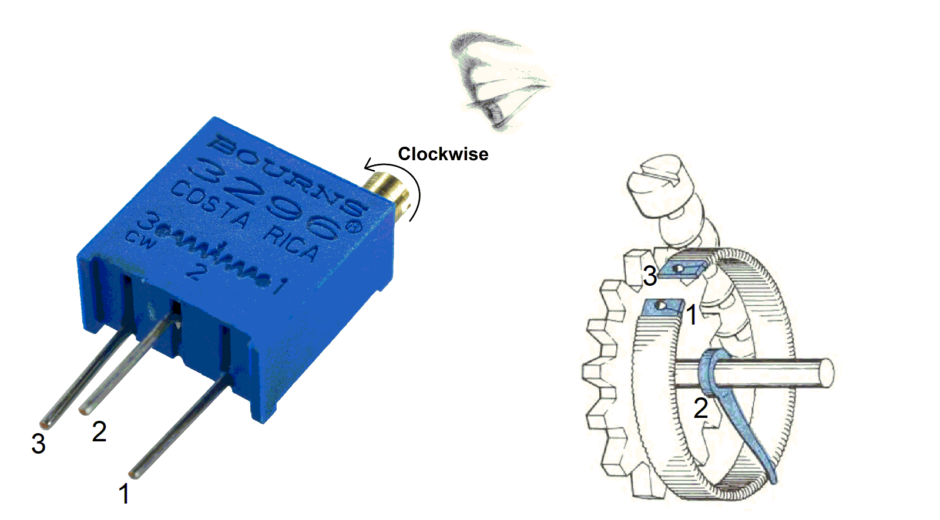

Figure : The internal structure of a 20-turn potentiometer.

**Configure the Audio Board**

Before you start work on today’s lab you need to perform an initial setup of your audio board. After soldering your components from last week your board will look something like that shown in Figure 2 with the exception of the components in the lower left corner, which you should NOT have installed.

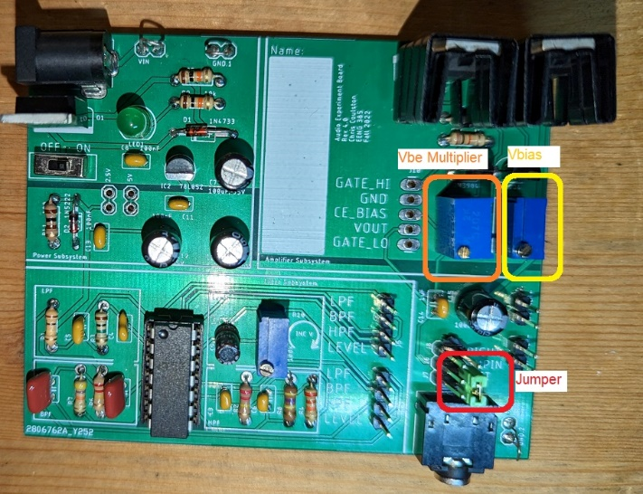

Figure : These are three items that need immediate attention before you start the lab. You should NOT have any components soldered into the lower left area of the board labeled LPF, HPF, BPF, LEVEL.

Note, if you soldered in your potentiometers upside-down, your brass screws will be towards the top of the board. Do not resolder your board, just reverse the CW, CCW directions in the instructions below.

* Vbe Multiplier POT
  + Turn the brass adjustment screw clock-wise at least 20 turns. Until it clicks
* Vbias POT
  + Turn the brass adjustment screw counter-clock-wise for at least 20 turns. Until it clicks.
  + Then turn the brass adjustment screw clock-wise for exactly 4 turns.
* Install a jumper on the lower two header pins on the right side.
* Grab a 3.5mm audio cable
* Grab a 2” speaker
* Login to the lab computers
  + Launch a web browser
  + Load youtube.com
  + Run the video “1000 Hz Sine Wave The Ultimate 10 Hour Test Tone | 1kHz”
  + Experiment so you know how to adjust the volume, then pause the video.

**Calibrate Vbe Multiplier**

Since we are using a Darlington pair for the T1 and T2, you will need to adjust the potentiometer R13 to establish a 2.4V difference across the Vbe multiplier. This will put 0Ω between the collector base junction and 1kΩ between the base emitter junction. This is turn will seperate the bases of the Darlington pairs by 0.7V, keeping the circuit as far away as possible from turning on both Darlington’s at the same time – a good thing. Apply power to the

Before applying power, setup a DMM with the positive probe in the GATE_HI header and the negative probe in the GETE_LO header. Start adjusting the POT as soon as you apply power. You will need to readjust the Vbe multiplier when you attach the speaker, but this voltage is a good start.

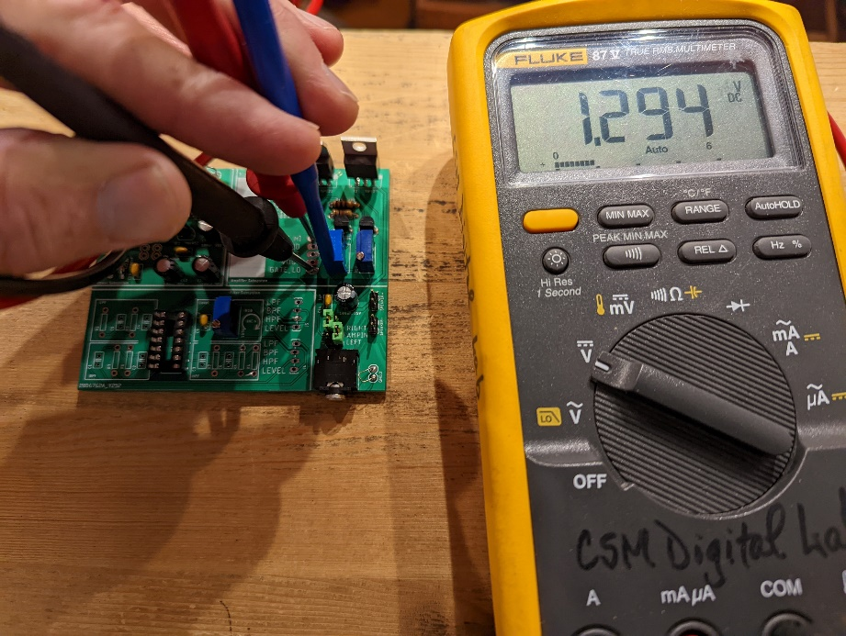

Figure : The setup to measure and adjust the Vbe multiplier. The voltage drop across the Vbe multiplier in the picture is set to 1.3V, just a smidge to high.

**Calibrate Bias Voltage**

Open your last week’s lab to your answers for the “**Compute the common emitter bias voltage**“ section. You need to adjust the potentiometer R12 so that the base of T4 is at VB (the answer to question 3). Before applying power, setup a DMM with the positive probe in the BIAS header and the negative probe in the adjacent GND header. Start adjusting the POT as soon as you apply power. You will have to fine tune this potentiometer when you connect a speaker, but this is a good start.

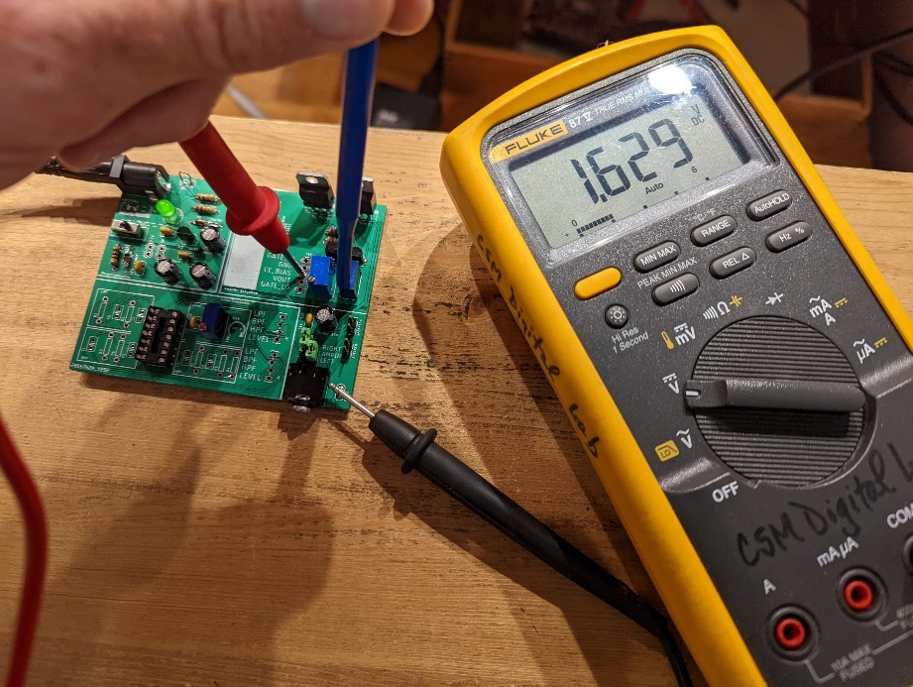

Figure : The setup to measure and adjust the bias voltage. The bias voltage of the Audio board in the picture is at 1.6V. I need to decrease this voltage by adjusting the POT labeled BIAS.

**Calibrate With a Signal**

Let’s apply a signal to the amplifier and fine tune the bias voltage and Vbe multiplier in preparation to apply an audio signal. We will start by applying a signal with a function generator and measuring the output using an oscilloscope with a speaker. To do this, first configure your oscilloscope as follows:

|  |  |
| --- | --- |
| Horizontal (scale) | 500us |
| Ch1 probe | VOUT header |
| Ch1 (scale) | 1mV/div |
| Ch1 (coupling) | DC |
| Trigger source | 1 |
| Trigger slope | ↑ |
| Trigger level | Vcc/2 (whatever Vcc you are using) |

Since this is the first time that we have used the Rigol DG1022Z function generators in our class, take a moment to identify the major areas of the front panel on the function generator sitting on your lab bench to those shown Figure 5.,

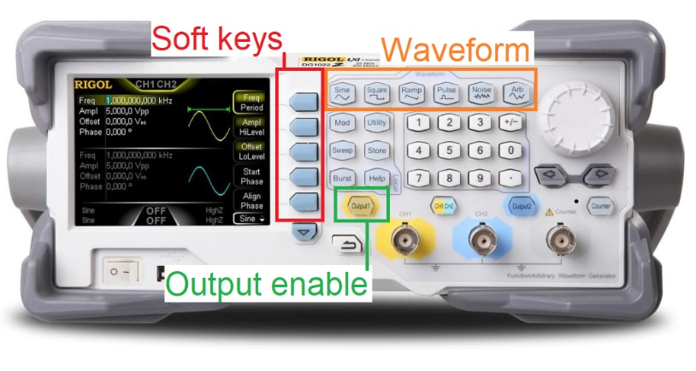

Figure : The Rigol DG1022Z function generator is a 2-channel function generator.

This 2-channel function generator allows you to independently configure the waveforms on Ch1 (yellow) or Ch2 (blue) by pressing the half yellow, half blue button labeled “CH1 CH2”. You can select the shape of the waveform using the Waveform buttons. Selecting a waveform changes the displayed choices to the left of the softkeys. Now get to pressing some buttons and configure the function generator as follows.

|  |  |
| --- | --- |
| Ch1 waveform | Sine |
| Ch1 Ampl/HiLevel softkey mode/value | HiLevel / 0.5 Vpp |
| Ch1 Offset/LoLevel softkey mode/value | LoLevel / 0 Vpp |
| Ch1 Freq/Period softkey mode/value | Freq / 1 kHz |
| Ch1 coaxial cable red/black | AMPIN/GND  Use a jumper wire to connect to AMPIN |

**Fine Tune Vbe Multiplier**

It’s important to get the Vbe multiplier tuned because this is the one items that will cause the output transistors to overhead. In other words, if your output transistors are overheating it’s almost certainly a result of your Vbe multiplier being mis-adusted. It is MUCH easier to set the BIAS voltage with a speaker attached.

Adjusting the Vbe multiplier changes when the T1 and T2 BJTs conduct. When you set the voltage across the Vbe multiplier too high, both T1 and T2 will conduct at the same time. This will cause a short circuit between the Vcc and GND rails causing very high power disipation in T1 and T2. When you set the voltage across the Vbe multiplier is set too low, there will be times when neither T1 and T2. This will cause a flat spot in VOUT and a distorted audio output.

Both of these unwanted situations are a mistiming in turning one of the output transistors on turing the other transistor on. This is called cross-over distortion because the output signal is crossing over from one of the transistors to the other. You need to adjust the Vbe multiplier so that the sinusoidal output has no cross-over distortion, so that output waveform has no distortions in the middle. Figure 6 shows how to adjust the VBE potentiometer to eliminate cross over distortion.

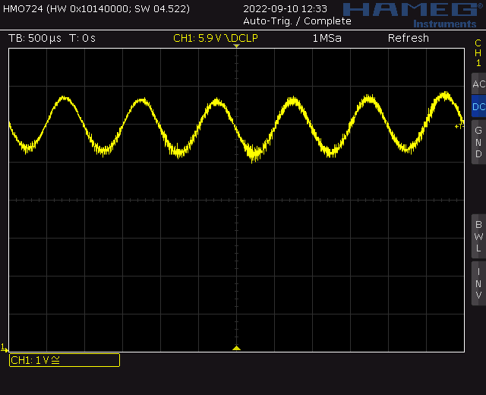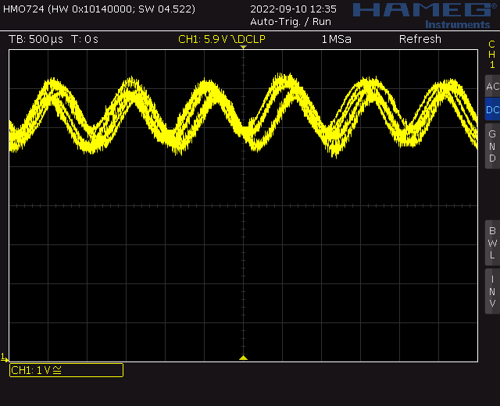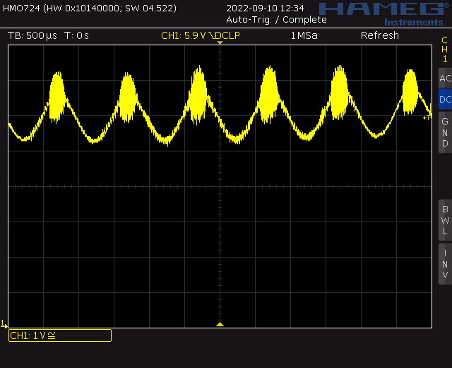

*Figure 7: Audio board being run with Vcc=12V and Vin = 1kHz sinusoid. Left, the Vbe multiplier is set too high causing leakage from Vcc. Center, the Vbe multiplier set too low causing unstable output. Adjust the VBE potentiometer between these two waveforms to produce a stable sinusoid with no distortion.*

**Fine Tune Bias Voltage**

Adjusting the bias voltage changes the DC operating point of the output transistors T1 and T2 in Figure 1 which in turn determines VOUT. You can think of the operating point as the average value of the VOUT signal, its middle value. Adjust BIAS so that the middle value of VOUT is Vcc/2. Since the DC operating point changes with the applied Vcc, you may need to re-adjust BIAS if you increase Vcc. Figure 7 shows how to adjust the BIAS potentiometer.

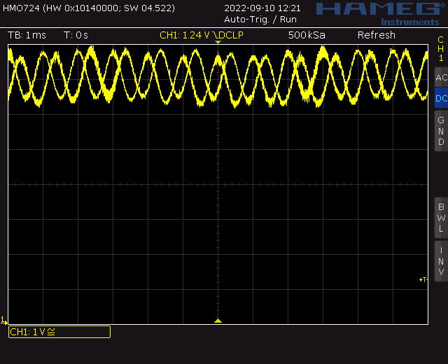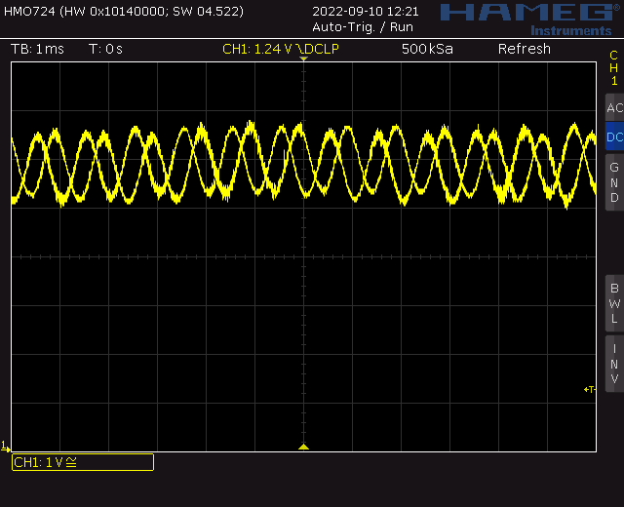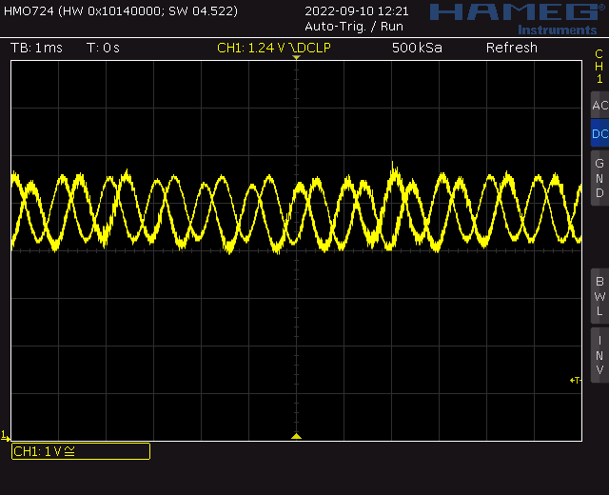

Figure : Audio board being run with Vcc=12V and Vin = 1kHz sinusoid. Left, the Bias voltage set too-low, around 5V. Middle, the Bias voltage set too-high, round 7V. For both of these cases, you should adjust the BIAS potentiometer to the image at right which is set just right at Vcc/2 = 6V.

**Amplifier Measurements**

Compute the voltage gain from the signal source to the Vout by forming the ratio of Vout amplitude over Vin amplitude. Note that this is the same quantity as the Vef/Vs ratio you computed in last week’s lab.

Some notes about this measurement:

* Center the input on the lower half of the oscilloscope display and center the output in the upper half.
* Use the Acquire function to smooth out the waveforms.
* Consider using the measurement tool to measure the amplitude.
* A 180° phase change from input to output represents a negative gain.

Screen shot the oscilloscope and use the values on the oscilloscope to compute the gain. The data shown in Figure 8 has a gain of 1140mV/129mV = -8.8. This is close to the gain of -10 that you should have gotten in last week’s lab for the unloaded Vef/Vs ratio.

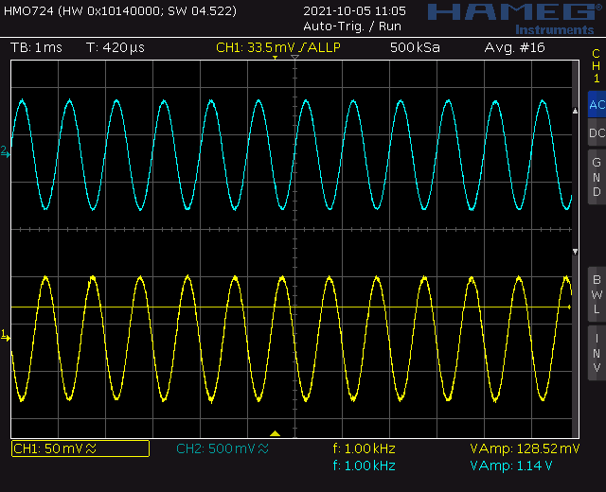

Figure : Oscilloscope capture of an unloaded common emitter input and output - no speaker attached.

Now connect a speaker to and screen shot the oscilloscope. Use the values on the oscilloscope to compute the gain of the loaded amplifier. The data shown in Figure 9 has a gain of 516mV/129mV = -4. This is close to the gain of -4.4 that you should have gotten in last week’s lab for the unloaded Vef/Vs ratio.

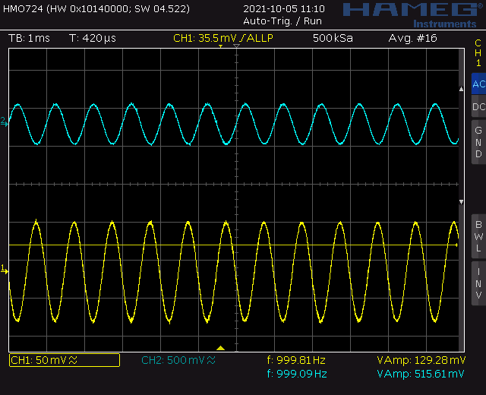

Figure : Oscilloscope capture of a loaded common emitter input and output – 8Ω speaker attached.

As a final test let’s use the oscilloscope’s built in frequency response subsystem to generate a Bode plot of the unloaded amplifier. To perform this test:

* Disconnect and turn-off the function generator.
* Connect the coaxaial cable that was on the function generator output of the oscilloscope. This connector is just above the power button.
* Configure the oscilloscope as follows:

|  |  |
| --- | --- |
| Ch1 probe | BIAS header |
| Ch2 probe | VOUT header |
| Coaxial red/black | AMPIN/GND |

* Press the Analysis button (just above the Ch2 vertical scale knob)
* Press the Features softkey and select FRA
* Make sure the setup tab (gear icon) is selected
  + Frequency Mode Sweep
  + Frequency (Start, Stop) 10Hz 1MHz
  + Points per decade 10
  + Source (Input, Output) 1 2
  + WaveGen 200mVpp 50Ω
* Press Run Analysis. The screen displays the input and output waveform as data is bring collected.
* The graph tab should auto select and display the Bode Plot for the audio amplifier.

**Apply an Audio Source**

This should be no surprise to you, but when you put on a pair of headphones to listen to music, your left and right ears hear slightly different audio producing stereo sound. The Audio board accepts stereo inputs from the 3-pole TRS cable shown in Figure 10. TRS stands for Tip, Ring, Sleeve; references to 3 metallic sections of the connector. You will connect an audio source to one end of the 3-pole TRS cable and the other end into the mating audio jack on the Audio board, at right in Figure 10. The left/right audio channel from the TRS cable will be available on the pair of headers labeled LEFT/RIGHT on the Audio board. Notice that the two LEFT headers are connected together with a wire (red line in Figure 10), so they carry identical signals. Same with the RIGHT headers.

You will apply a signal to the AMPIN header in Figure 10 to send an audio signal to the amplifier. The header pins in Figure 10 are placed 0.1” apart so you can use a 2-pin jumper to connect the LEFT or RIGHT audio channel to AMPIN. Unless you are dealing with a mono audio source (an audio source with a single channel), it does not matter if you send the LEFT or RIGHT audio channel to the AMPIN pin.

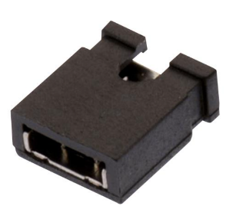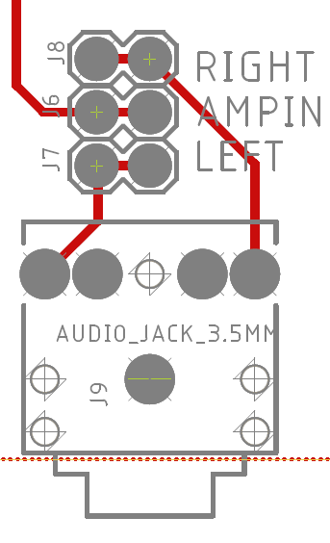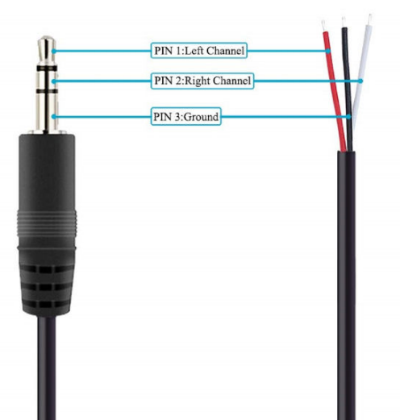

Figure : left, a 3-pole TRS cable audio cable. Center, the Audio board stereo input connector and associated header pins. Right, a 2 pin jumper used to connect the LEFT or RIGHT audio channel to AMPIN.

Once you have everything setup enable the audio output of your signal source and listen to the output. Enjoy, you’ve earned it.

# Turn In

Make a record of your response to numbered items below and turn them in a single copy as your team’s solution on Canvas using the instructions posted there. Include the names of both team members at the top of your solutions. Use complete English sentences to introduce what each of the following listed items (below) is and how it was derived.

**Amplifier Measurements**

Screen shot of input and output with no-load

Calculation of no-load gain

Screen shot of input and output with 8Ω speaker

Calculation of 8Ω gain.

Bode plot for amplifier

**Apply an Audio Source**

Demo working amplifier by playing a song